Setting up application Environment

**Docker CLI Installation**

|  |  |  |
| --- | --- | --- |
| Name |  | Vignesh M |
| Roll No |  | SSNCE195001128 |
| Team ID |  | PNT2022TMID53102 |
| Project Name |  | Skill and Job Recommander |

Step 1:

Go the official Docker website: ***[https://docs.docker.com/desktop/install/windows-](https://docs.docker.com/desktop/install/windows-install/) [install/](https://docs.docker.com/desktop/install/windows-install/)*** and install it by running Desktop Installer.exe file

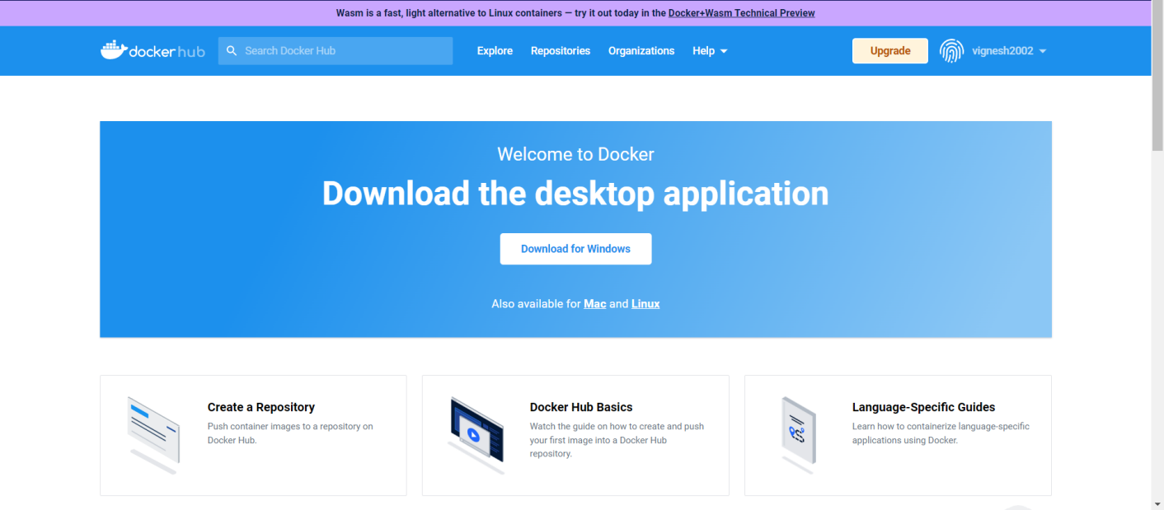

**Step 2:**

Goto hub. docker.com register and create an account and login with the same

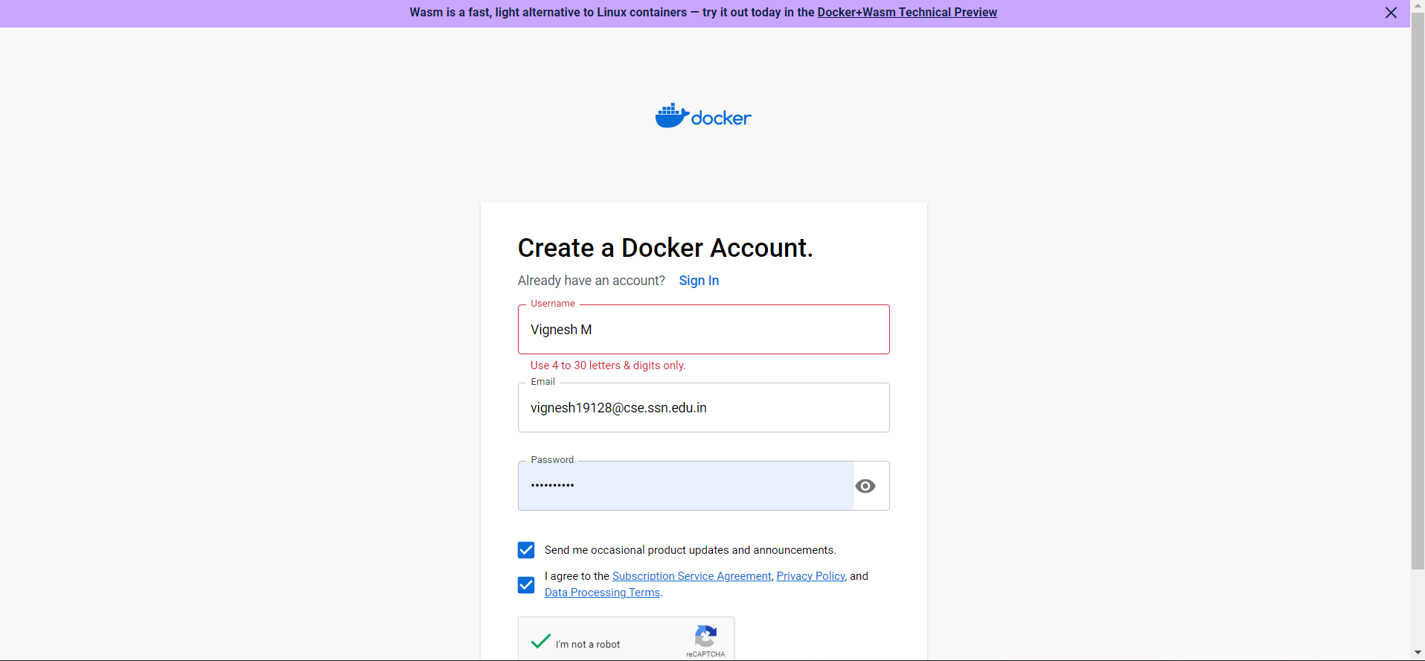

# Step 3:

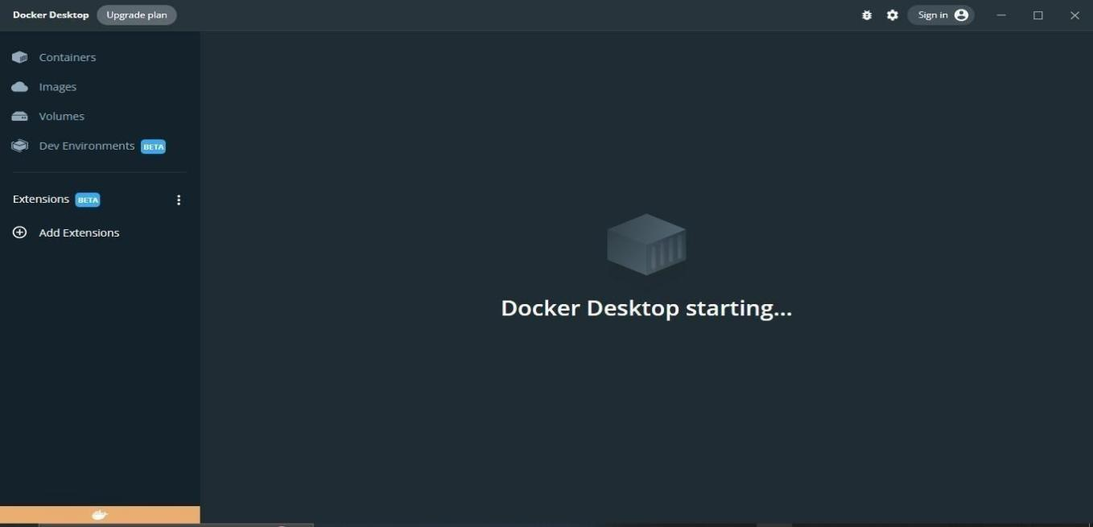Open Docker Desktop and start creating containers and images.